Building Shapes

The shapes of all buildings are structured in three different categories:

**Tetris =** original Tetris shapes

**Block =** Shapes have a block layout without any curves

**Special =** Shapes can have any kind of form, even curves

The Tetris shapes are for buildings which are often used, so they are easily to build close to other buildings.

The Block buildings are less often used but with the Shape they should be not to hard to be built into the city.

The special shapes should create the depth in the game because they don’t really fit in.

**Tetris Shapes:**

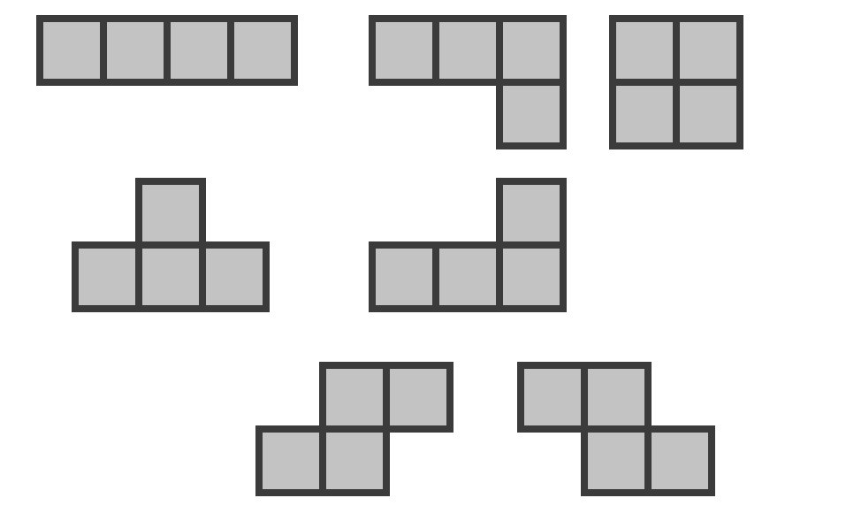

**Block Shapes:**

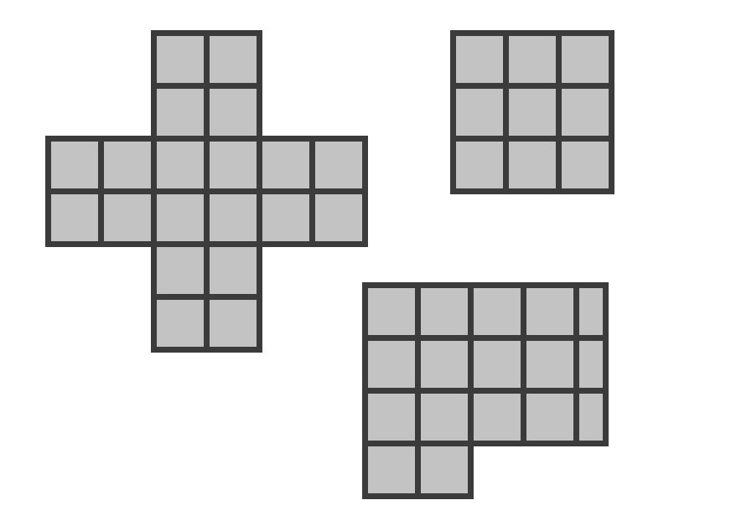

**Special Shapes:**

(These are only examples. The shapes should be able to be adapted to the idea and concept of the buildings.)

